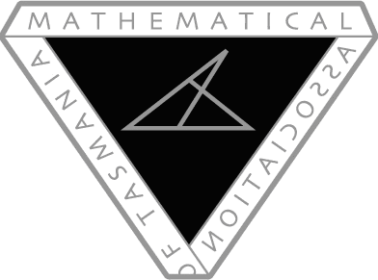
Mathematics Association of Tasmania Conference

Sat 13th May (9am – 3:30pm)

To infinity and beyond: Are we there yet? Presenter application form
Presenters are asked to email the following details to bstephenson@gyc.tas.edu.au by April 8th, 2017
Presentation name:
Presenter(s) name:
Audience: Early Childhood/Primary/Secondary/Senior Secondary/General
Abstract (100 words):

For more information, please contact Brett Stephenson (BStephenson@gyc.tas.edu.au) and keep an eye on MAT’s website (mat.aamt.edu.au)

